AL-FARABI KAZAKH NATIONAL UNIVERSITY | 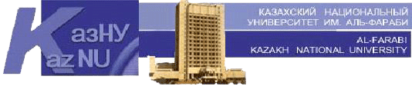

Faculty of Philology and World Languages

Confirmed by
Dean of the faculty
______________ B.U.Dzholdasbekova
№ __, ________ __, 20__

Methodical recommendations for the preparation of EMCD:
“Map of educational and methodical provision of the discipline”

Discipline Scientific Writing
Course/Specialty 2course
Semester 4

№ | Textbooks and tutorials | Internet Resources | Quantity in the library | % of sufficiency
1. | A guide for scientific writing, Utrecht University press, 2015. | + |  | 100%
2. | Academic Writing. A handbook for international students. Stephen Bailey. Routledge.2011. | + |  | 100%
3. | 1.Brian Paltridge and Sue Starfield. Thesis and dissertation writing in a second language. A handbook for supervisors. Taylor & Francis e-Library, 2007. | + |  | 100%
4. | 3. Введение в научное исследование: Учебное пособие для студентов (Под ред. В.И. Журавлева. – М.: Высшая школа, 2008. – 270с. | + |  | 100%
5.

Considered and recommended at the meeting of the Department of General Linguistics and European Languages
Protocol № __, ________ __, 20__
Head of the department _____________________ G.B. Madiyeva

Confirmed by methodical bureau of the faculty
Protocol № __, ________ __, 20__

Chairman ________________________ L.V. Ekshembeeva

